**Code**

*RunMe File*

l = 1;

g = 10;

tspan = [0,66];

PendHWProb(tspan,g,l)

*Main Function*

function PendHWProb(tspan,g,l)

xin = [pi/18,pi/12,pi/6,pi/3;0,0,0,0];

xmin = [0,0,0,0];

xmax = [.2, .3 ,.55, 1.15];

ymin = [0,0,0,0];

ymax = [.6, .85, 1.75, 3.5];

n = size(xin,2);

options = [];

markers = {'x','o','*','s','d'};

colors = {'b','g','r','bl','c','m','y'};

sAng = {'pi/18', 'pi/12', 'pi/6', 'pi/3'};

for kk = 1:n

figure;

title({['\fontsize{16} Phase Plot for Pendulum, Quad 1, Starting Angle: ' sAng{kk} ' '] ; 'Comparison of Linear Approximation To Non-Linear Equations '});

xlabel('\fontsize{13} Angular Velocity (rad/sec) ');

ylabel('\fontsize{13} Angular Displacement (rad. from horizontal) ');

axis square

axis([xmin(kk),xmax(kk),ymin(kk),ymax(kk)]);

hold on;

for ii = 1:2

[~,s] = ode45(@odetest, tspan, xin(:,kk), options,ii, g,l);

plot(s(:,1), s(:,2),'LineStyle', 'none', 'Marker', markers{ii},...

'MarkerFaceColor', colors{ii}, 'MarkerEdgeColor', colors{ii}, 'MarkerSize', 9);

if ii==2, legend('\fontsize{14} Non-Linear Case','\fontsize{14} Linear Case'); end

end

end

hold off;

% end

function xprime = odetest(~,x,ii,g,l)

% x(1) = x

% x(2) = y

switch ii

case 1

gp = @(xin) -g*l*sin(xin);

case 2

gp = @(xin) -g*l*xin;

end

xprime(1) = x(2);

xprime(2) = gp(x(1));

xprime = xprime(:);

*Mod For Interval Plots*

[~,s] = ode45(@odetest, tspan, xin(:,4), options,ii, g,l);

TestIndex = (1:50:(length(s)-100))+100;

hold on;

plot(s(TestIndex,1),s(TestIndex,2),'LineStyle', '--', 'Marker', 'o',...

'MarkerFaceColor', 'r', 'MarkerEdgeColor', 'r', 'MarkerSize', 9);

hold off;

**Results**

Since the plots are symmetric (essentially), for the basic plots, only the 1st quadrant for each starting conditions was plotted, so as to better observe the details of the paths taken. The last two plots are a more telling comparison of the linear and non-linear cases for the maximum starting angle simulated, pi/3. The plots are only of points at distinct intervals (with approximately equal spacing), and the lines shown connect adjacent samples. That is, if two points are connected, then they are spaced one interval apart.

Note that for small initial angles, namely the first two plots, the linear and non-linear simulations perform similarly. It is only at larger deviations that major discrepancies begin to manifest. While it appears that there is only a shift in the region of phase space the two cases occupy, from the interval plots, it is clear that an entirely different pattern has emerged for each. The linear case is seen to be located at discrete locations in the phase space, and the adjacent points for each location are fixed. The non-linear case displays a seemingly random collection of phase-space points with no pattern for adjacent points.

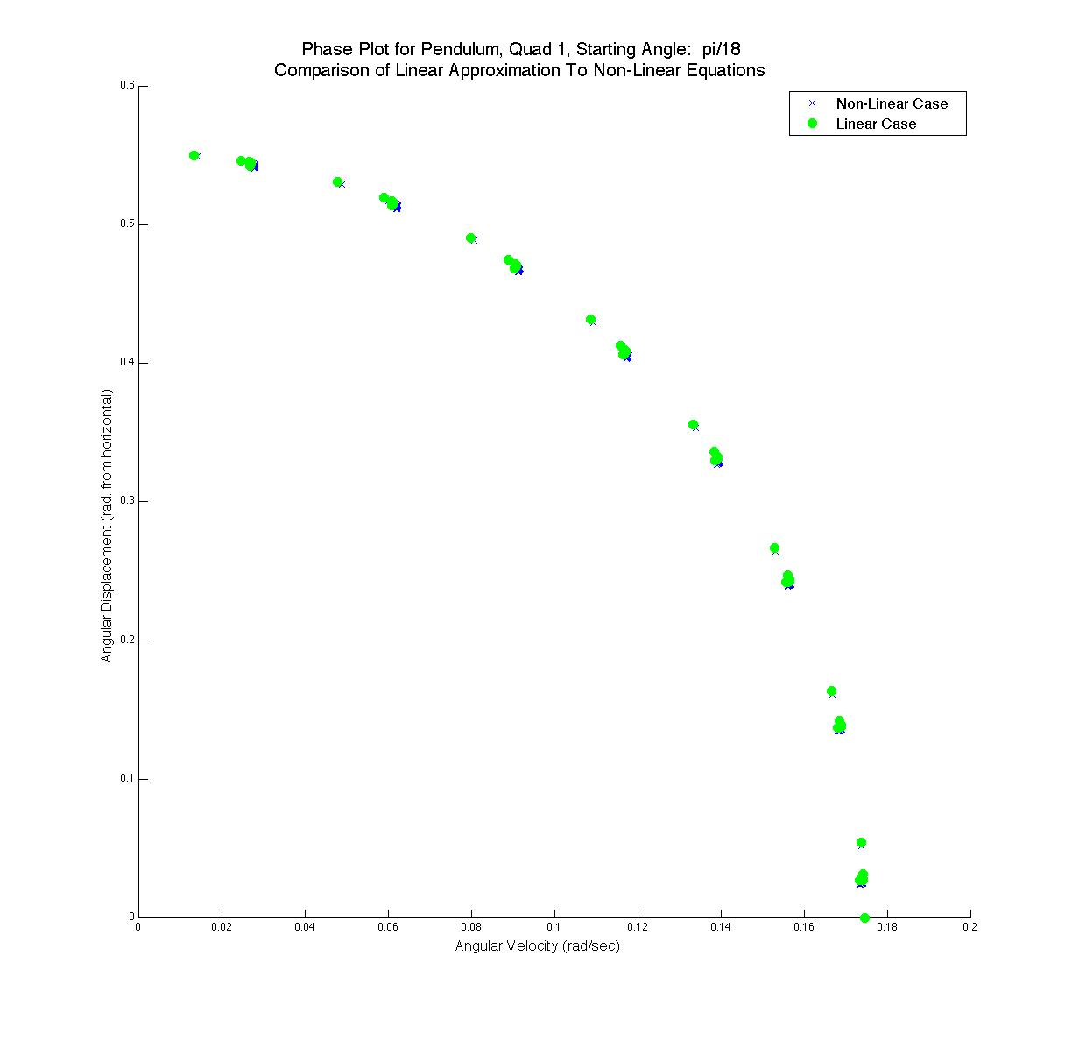

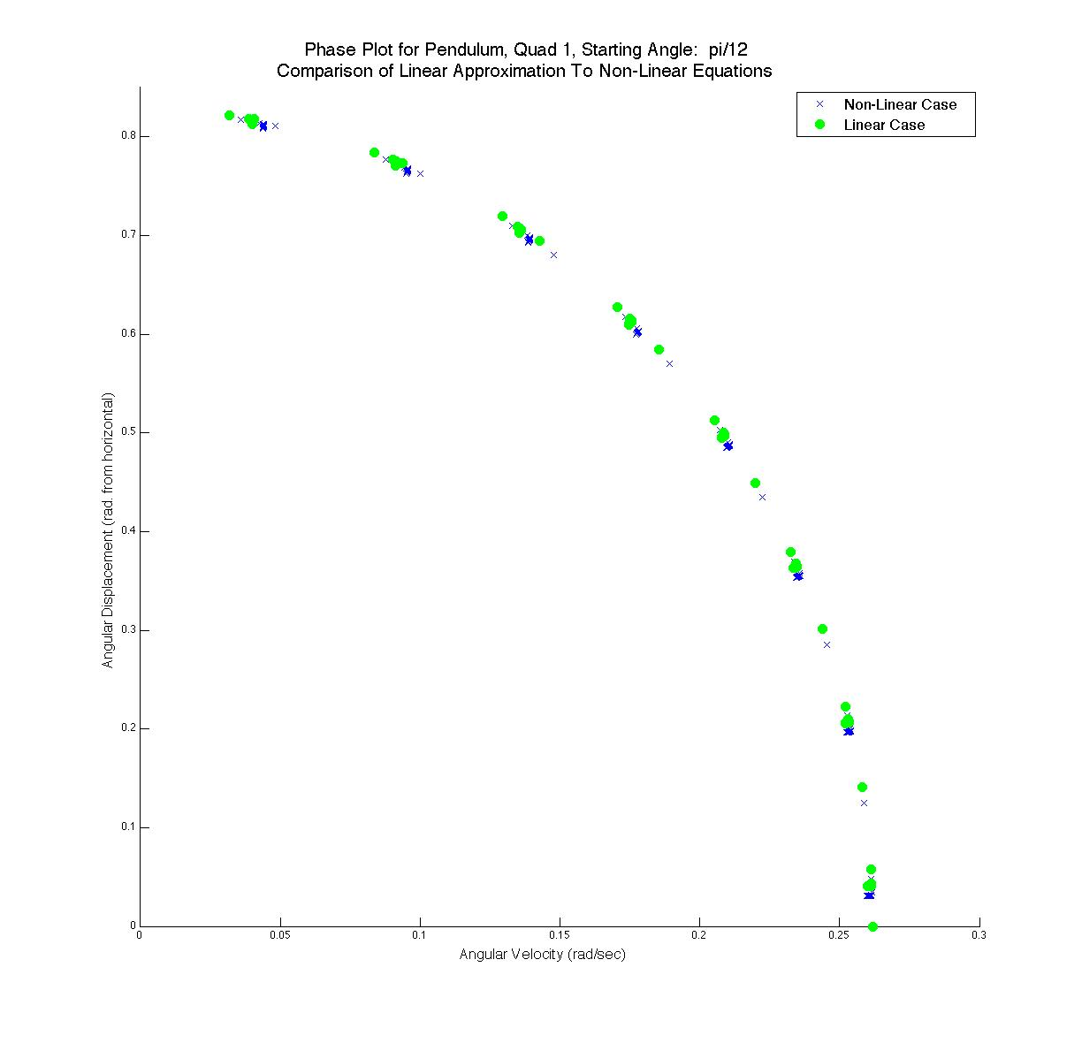

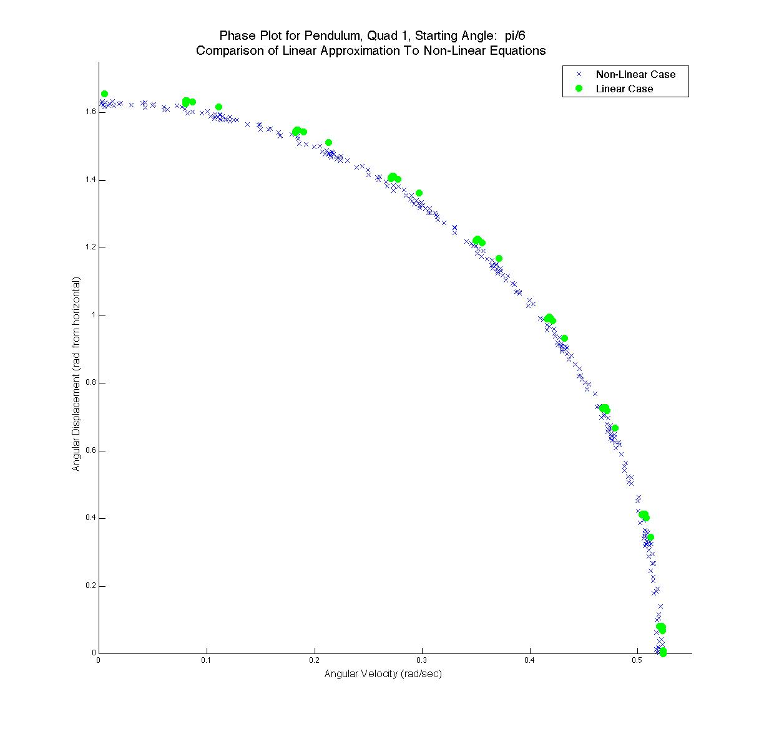

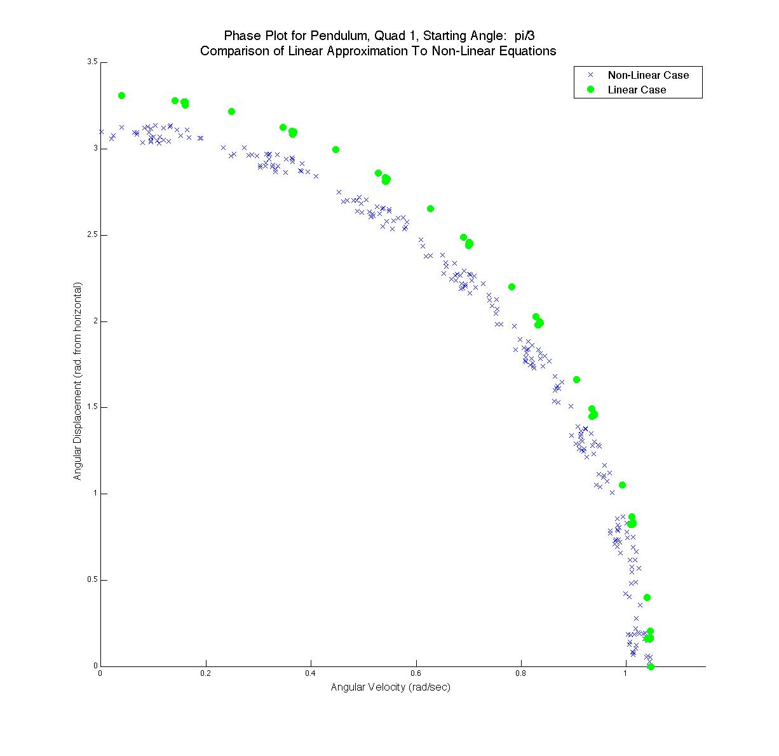

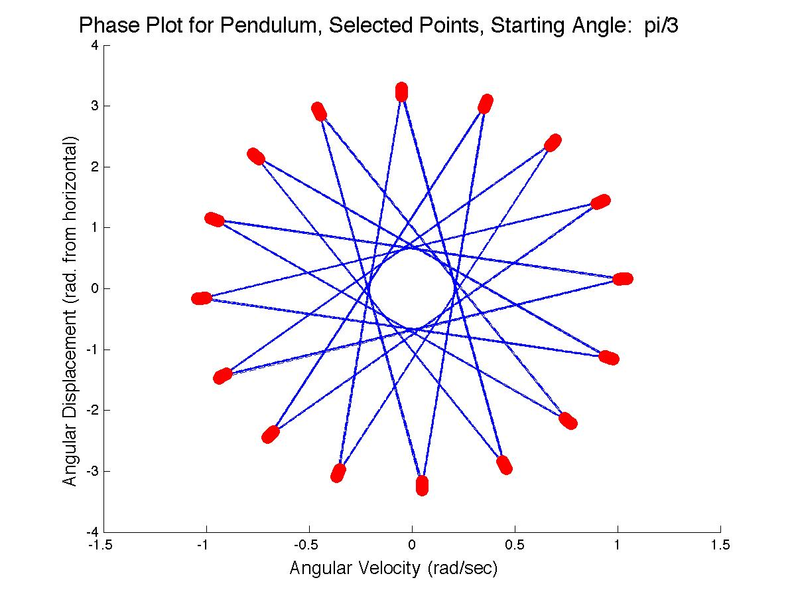

Linear Case

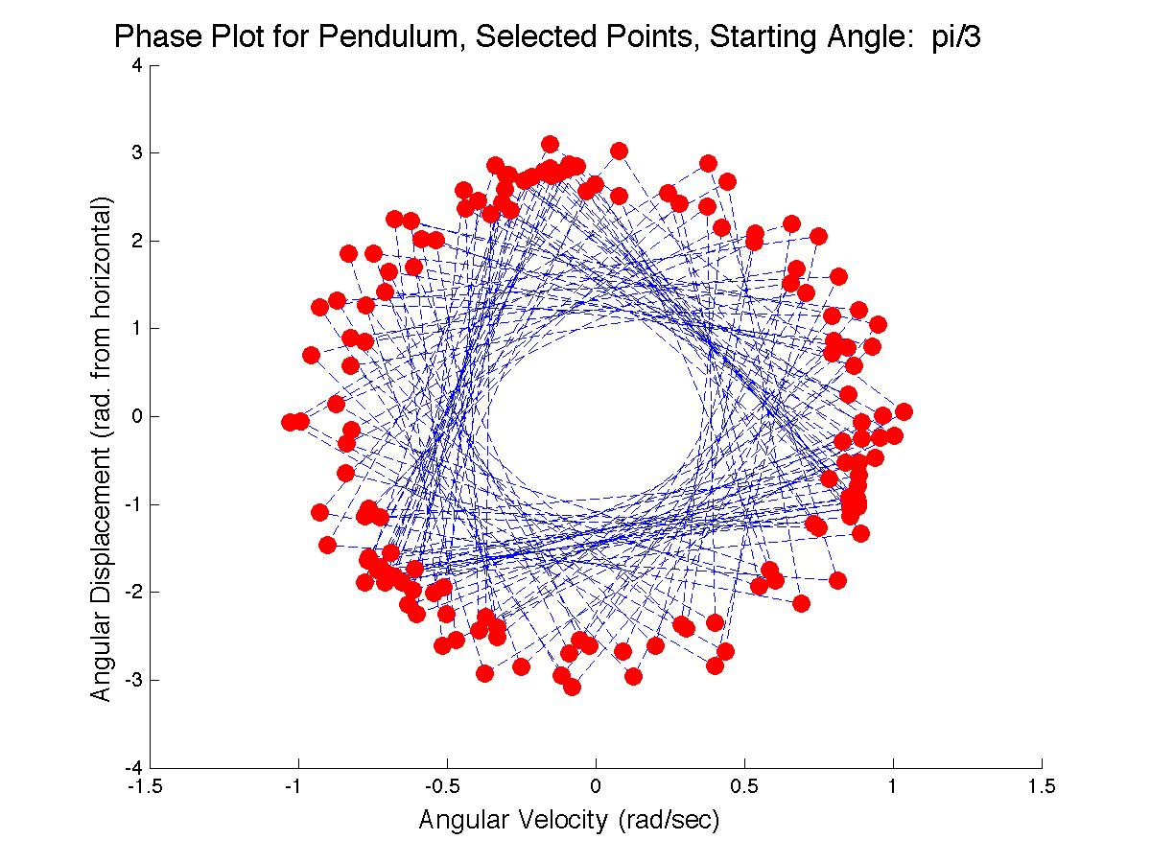Non-Linear Case